Saint Mark Orthodox Church
Orthodox Church in America  Diocese of Washington  7124 River Road  Bethesda, MD 20817  Church Office: 301-229-6300  www.saintmarkoca.org |  |  |  |  | Rector  V. Rev. Gregory Safchuk  Office: 301-229-6300  Home: 301-320-0739  gsafchuk@hotmail.com  admin@stmarkoca.org |  | Parish Council President:  Michael Thompson  Home: 703-204-9092  dunaad@msn.com

HOLY PASCHA APRIL 12, 2015
EPISTLE  Acts 1:1-8 |  |  |  | GOSPEL  John 1:1-17
DIVINE LITURGY OF ST. JOHN
HOLY PASCHA – THE RESURRECTION OF OUR LORD AND SAVIOR JESUS CHRIST. [Beginning of the Pentecostarion.] St. Basil the Confessor, Bishop of Parium (8th c.). Hieromartyr Zeno, Bishop of Verona (ca. 260). Ven. Isaac the Syrian, Abbot of Spoleto (550). Monk Martyrs Menas, David, and John, of Palestine (7th c.). Ven. Anthusa the Virgin, of Constantinople (801). Ven. Athanasia, Abbess, of Aegina (860). Ven. Acacius the Younger, of Kavsokalyvia (Mt. Athos – 1730).
Saturday | Apr | 11 | 11:30p |  |  | Nocturn, Matins, & Divine Liturgy of PASCHA
Sunday | Apr | 12 |  |  |  | PASCHA – CHRIST IS RISEN!
 |  |  | ~2:30a |  |  | PASCHA Agape Meal in Fellowship Hall
Monday | Apr | 13 | 10:00a |  |  | Divine Liturgy – Bright Monday
Tuesday | Apr | 14 | 7:00p |  |  | Parish Council Meeting
Saturday | Apr | 18 | 8:00a |  |  | Men’s Fellowship Breakfast, in Fellowship Hall
 |  |  | 5:00p |  |  | Private Confession
 |  |  | 5:30p |  |  | Great Vespers
 |  |  | 6:30p |  |  | FOCA Chapter Meeting
Sunday | Apr | 19 | 9:30a |  |  | Divine Liturgy – St. Thomas
 |  |  | 11:30a |  |  | Coffee Hour
 |  |  | 11:30a |  |  | Lean Plate Club Meeting
 |  |  | 11:30a |  |  | Basics of Orthodoxy Class
 |  |  | 11:45a |  |  | Church School & Easter Egg Hunt
CONTINUED ON LAST PAGE >>>
Tuesday | Apr | 21 | 10:30a |  |  | Bl. Mat. Olga Prayer Group – Akathist Prayer
Saturday | Apr | 25 | 9:30a |  |  | Divine Liturgy- St. Mark Patronal Feastday
 |  |  | 4:30p |  |  | Memorial Service for Fr. Thomas Hopko (40th day)
 |  |  | 5:00p |  |  | Private Confession
 |  |  | 5:30p |  |  | Great Vespers
The Altar Candles are donated by Marilyn Macht in celebration of the birthdays of her brother, Henry Schuett and granddaughter, Chloe Little. God Grant Them Many Years!
The Sanctuary Candles are donated by Drs. Anna and Mary Nemesh in loving memory of parents, Charles and Annie Nemesh, and brother, Dr. Walter Nemesh. May Their Memory Be Eternal!

Coffee Hour
Date | Hosts/Hostesses |  |  | Donuts/Bagels
Apr 12 | PASCHA
Apr 19 | E. Barber | J&K Barber | Sekellick |  | Phelps

Choir Directors, Readers, Preparers, Greeters, Altar Servers and Handmaidens
Date | Director | Reader | Preparer | Greeter | Altar  Servers | Hand-Maidens
Apr 12 | M. Ahmadi  C. Berencz  D. Hardy | J.  Bilyeu | PASCHA | PASCHA | A. Ahmadi  A. Datch  P. Dillon  T. Dillon  F. LeFors  V. Lutes  L. Prentice  J. Sedor  M. Sedor | S. LeFors  A. Lyubimov  K. Prentice  J. Rudin
Apr 19 | W.  Tatusko | K.  Lungociu | P.  Antich | Mat. Phelps  &  N. Stanton |  | E. Datch  N. Hottle  J. Jankovic  E. Sedor

WELCOME VISITORS: We're delighted that you've come to join us here at St. Mark in worshipping God. Please take a moment to fill out a visitor card located in our pews, and drop it off in the basket on the candle counter in the church vestibule, or sign our guest book. Thanks very much.
PRAYER REQUEST – O Christ, You alone are our Defender: Visit and help Thy servants who are in need of your help, protection and healing. Among them: John & Marti Badila; Arvid and Justin Daniel; Paul Dean; Zachary Firestone; Julie Flick; Marge German; Juretta Heckscher; Alice Krenitsky; Evelyn Leleck; Larisa Looby; Marina McKee; Catherine Mikuluk; Karen Nichols; Matthew, Stacy and Baby Nimmer; Timothy Parrish; David, Susan and Isaiah Rodak; Alexandra and John Sedor; Katie Sheppard; Peter Sielinski; Cathy Tatusko; Andrea Ticich; and Peter Truitt.

Please pray for Margaret, Mary Carol Ashley’s mother; Tina Burpee's sister-in-law Linda who was diagnosed with adenocarcinoma and her friend Nelson who was diagnosed with cancer of the tongue; Christine Cacic’s aunt, Catherine Stauder; Debbi Dillon’s mother-in-law, Charlotte; Julie Flick’s son, James Shimer, and her stepdaughter, Jeanie Folton; Marge German’s brother, John, her grandson, Joshua, and her friend, Kema; Juretta Heckscher’s husband Ken, niece, Anna, and friend Jacob; Olga, friend of Helen Kerch; Mat. Jan and Fr. Mark Koczak’s friend, Metropolitan Isaiah (Georgian Patriarchate), John & Ekaterine, the parents of departed infant Damian, and Alla, Alexey, Svitlana (and their families); Mary Everhart, mother of Ted Koopersmith; Rachel LeFors’ friend, Ilene, who has been diagnosed with cancer, and her uncle, John who is fighting cancer; Larisa Looby’s friend, Valentina; Michael Lungociu’s father, Nicholas Lungociu and friend’s mother, Gitta Finch; Paulina Masick’s brother, Philip; Judi, Joan Mitchum’s sister; Jim Orban’s daughter, Rebecca; Kyla Prentice’s friend, Ashley; Kathy Rudin’s friend, Ben Crawford; Gale Rutan’s father-in-law, Joseph; Julia Shiller’s father, Vadim Pyatovolenko; Peter Sielinski’s friends Brenda & Jim Hall, Kelly, Samuel, Ron, Pat, Bailey, Jenn and Matt; Olga & Slavina Skenderska’s cousin, Stanislav, and friends Catherine & Justin; Ellen Thompson’s daughter, Sonya; Jan & Don Truitt’s parents; Linda Weir’s mother, Ruby; Paula Zabela’s cousins Kathleen and Frances, who are afflicted with cancer; Zachary (Zecchaeus) Jensen, member of St. John the Baptist Orthodox Church in Thurmont, MD, who is recovering from severe head injury; and Paniota who is sick.

Deliver them from sickness and grievous pains. Raise them up that they may sing to Thee and praise Thee without ceasing, through the prayers of the Theotokos and all your Saints!
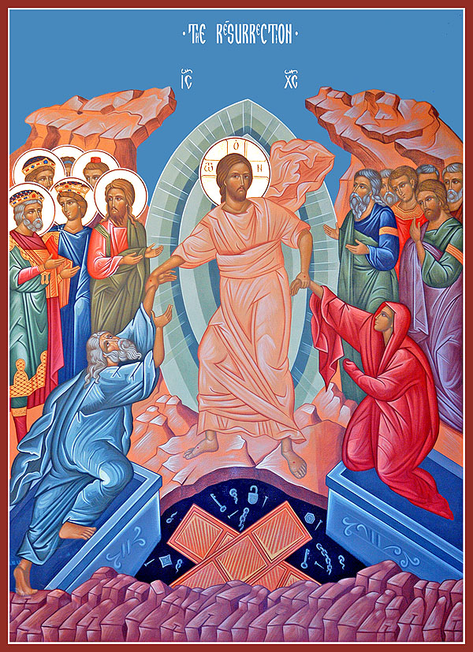
CHRIST IS RISEN! INDEED HE IS RISEN!
PASCHAL AGAPE MEAL: CHRIST IS RISEN!! Stay to break the fast and share a meal following the Resurrection Liturgy on PASCHA in our parish Fellowship hall. Many people bring baskets of food to be blessed and then enjoy that food together. A common table will be available for all to share as well! If you’re able to bring something to put on the common table to be shared by everyone, it would be greatly appreciated. Thank you.
THERE WILL BE NO SUNDAY SCHOOL ON PASCHA, SUNDAY, APRIL 12TH.
BRIGHT MONDAY DIVINE LITURGY will be served on Monday, April 13th at 10:00 AM.
PARISH COUNCIL MEETING will take place this Tuesday, April 14th at 7:00 PM. All are welcome to attend.
MEN’S FELLOWSHIP BREAKFAST will take place this Saturday, April 18th at 8:00 AM in the Fellowship Hall. The format of future fellowship meetings and activities will be discussed. The tentative plan is to hold a breakfast on a monthly basis, followed by rotating activities such as Bible study, group prayer, a service activity, or recreational activity.
2015 COLONIAL DISTRICT FOCA STOCK AWARD DRAWING will take place at the St. Mark FOCA Chapter 229 meeting this Saturday, April 18th after Vespers. Be sure to attend the meeting to find out who the winners will be. Visitors welcome.
FR. TIM PERRY’S BASICS OF ORTHODOXY CLASSES are on-hold, and will resume next Sunday April 19th.
CHURCH SCHOOL EASTER EGG HUNT will take place next Sunday, April 19th following Liturgy and an abbreviated church school lesson.
LEAN PLATE CLUB meeting will take place next Sunday, April 19th following Liturgy.
BLESSED MAT. OLGA OF ALASKA WOMEN’S PRAYER GROUP will meet at 10:30 AM on Tuesday, April 21st to pray the Akathist – Glory to God For All Things! If you would like the group to remember someone in prayer, please give their name to Debbi Dillon, Marcella Hydock, or Mat. Alexandra.
ST. MARK PATRONAL FEASTDAY is on Saturday, April 25th. In celebration, we will have Divine Liturgy at 9:30 AM on that day.
MEMORIAL SERVICE will be held for Fr. Thomas Hopko on Saturday, April 25th at 4:30 PM in observance of his 40th day of passing. May His Memory Be Eternal!
WOMEN’S BOOK CLUB will meet on Sunday, April 26th after Liturgy. The group will discuss the book: “The Mirrored World: A Novel” by Debra Dean, a novel about the life of St. Xenia. Debra Dean, the author, plans to join us by FaceTime for a discussion of the book during our time together on April 26th. Please join us!
OCMC BENEFIT BANQUET will take place on Sunday evening, April 26th at St. Katherine’s Greek Orthodox Church, 3149 Glen Carlyn Road, Falls Church, Virginia 22041. Vespers will be at 5:00 PM, Hors d'oeuvres at 5:30 PM, followed by dinner at 6:00PM. Listen to Fr. John Chakos speak on: “Orthodoxy in the Guatemalan Highlands: A Light Shines Brightly”. Cost to attend is: Tables for Ten: $500; Adults: $55; Students: $30; Under Six ‐ Free. For further information, contact Skip Mersereau at: jwmster@gmail.com.
PIROGHI & BLINI LUNCHEON will be held on Sunday, May 3rd following Liturgy. The proceeds from this free-will offering luncheon will be used towards ingredient purchases for our 2015 bazaar. We hope to see you there!
ST. MARK ANNUAL RUMMAGE SALE will be held on Saturday, June 13th from 8:00 AM – 2:00 PM. SAVE THE DATE and please begin collecting your gently used items for donation! Donations can be brought in after Church School on May 10th and may be placed in the lower level double classroom near the exit. Handouts detailing what donated items can/cannot be accepted are available at the candle counter. Volunteers are needed starting on Sunday, May 10th to begin sorting and pricing of donations. Also, please begin saving large shopping bags to use for packing customer purchases. Any questions, call Marsha Zellem at: 301-881-3407. As always, thanks for your help in making this annual event a success!
THANK YOU to all who donated to the special collection for Catherine Dillon’s and Kara Yakubik’s missionary trips. A total of $1085 was collected. Thank you for your support of our St. Mark missionaries!
THANK YOU: To all who helped bake, cook, decorate, set up, tear down and organize things around our church for Holy Week and Pascha. Special thanks to our choir, directors, readers and servers for all their hard work and time spent practicing and preparing for services. Your efforts have added greatly to the beauty and joy of this Holy season. Thank you!
CONGRATULATIONS to David and Cindy Jefferson who were Baptized and Chrismated yesterday! God Grant them MANY YEARS!
JOB OPPORTUNITIES Northrop Grumman has 157 engineering positions available. They are looking for 2 to 5 years’ experience in several engineering fields. If you or someone you know are interested please call Michael Lungociu at 301-762-2926 or email Michael.Lungociu@ngc.com.
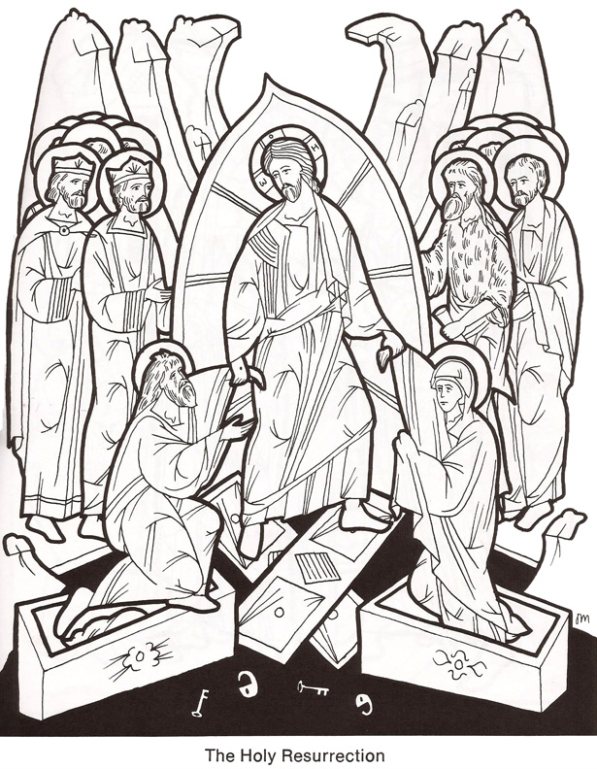
THE RESURRECTION
KIDS’ COLORING CORNER
THE RESURRECTION
KIDS’ COLORING CORNER

