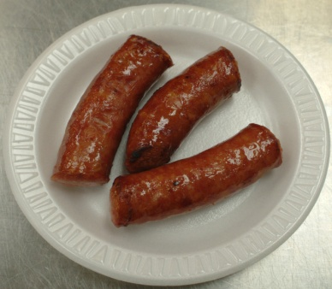

The annual St. Mark Orthodox Church Food Festival & Bazaar is known for its Russian and Eastern European food specialties, such as piroghi, piroshki, pirog, halupki, Chicken Kiev, Beef Stroganoff, kielbasa, blini, spanakopita, borscht, and assorted side dishes. Desserts and beverages are also available.  Dine in or carry-out.  Shop for breads and baked goods, religious books, icons, jewelry, pottery, handmade items & other one-of-a-kind gifts.  Watch an icon writing demonstration, visit the lucky draw room, or take a guided church tour to see our beautiful new Byzantine icons.  Ten percent discount on hot foods for seniors (65+). | 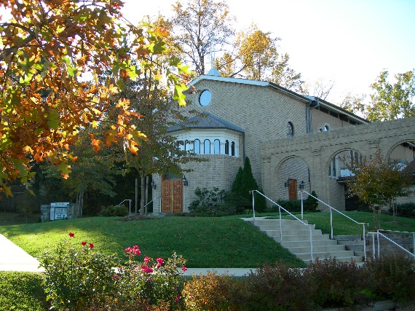  New Hours!  Fri. Nov 4 11 am – 7 pm  Sat. Nov 5 11 am – 7 pm  Sun. Nov 6 12 pm – 4 pm  St. Mark Church  is located at  7124 River Rd.  Bethesda, MD 20817 | Free Parking  and Admission  - Ethnic foods  - Desserts and candies  - Breads & baked goods  - Beverages  - Religious books & gifts  - Hand-painted icons  - Hand-carved wooden Ukrainian nesting dolls and figurines  - Jewelry  - Pottery  - Fabric art  - Hair accessories  - Scarves and shawls  - Christmas items  - Lucky Draw  - Church tours  - and more…  For more information call  301-229-6300 (office)  301-229-9720 (kitchen)  or see our website at  www.stmarkoca.org

